ONSET 변경 실험
□ ONSET 변경 조건
- v2_1: ONSET 이후로만 윈도우 쉬프팅 (기존: 낙상 40% 포함하도록)
- v2_2: ONSET 이후로만 윈도우 쉬프팅 & ONSET 0.7s 제한
└ window 1개 데이터가 25frame(0.5s)이므로, 리드타임 200ms까지 고려한 수치
□ 데이터셋 분포 확인
[기존]
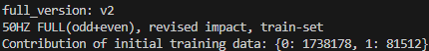
[v2_1]
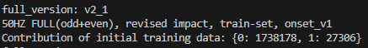
[v2_2]
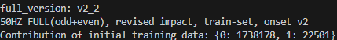
□ Full Training model 성능
[기존]
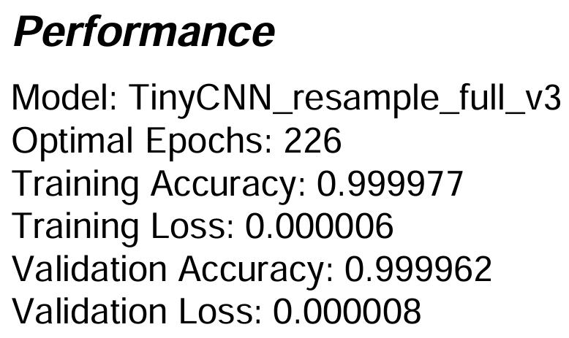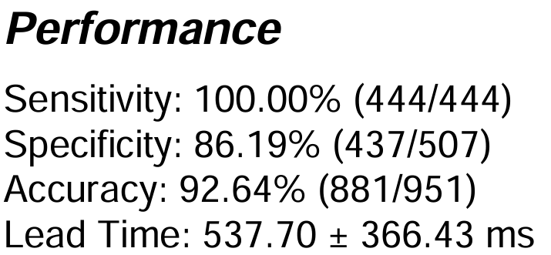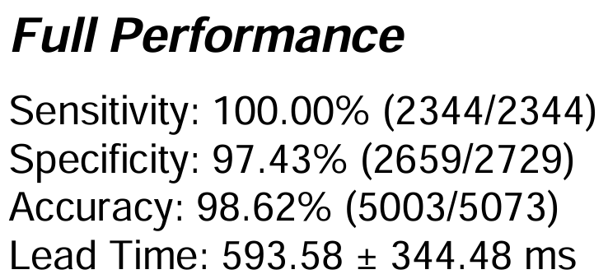
[v2_1]
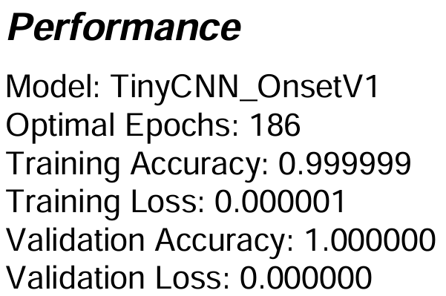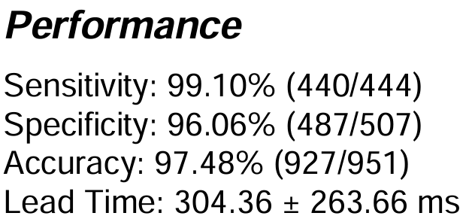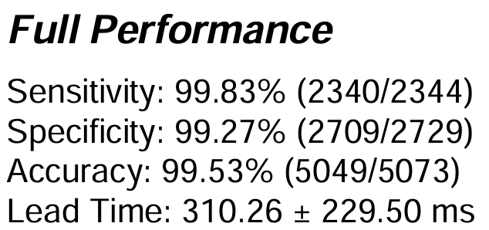
[v2_2]
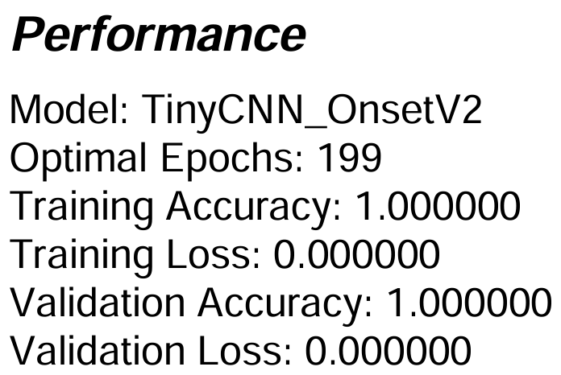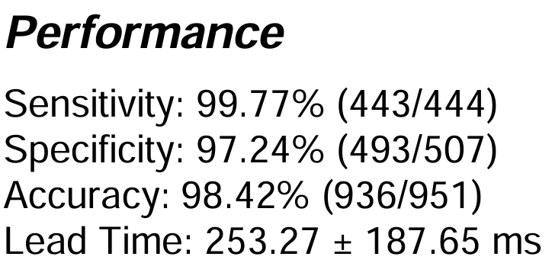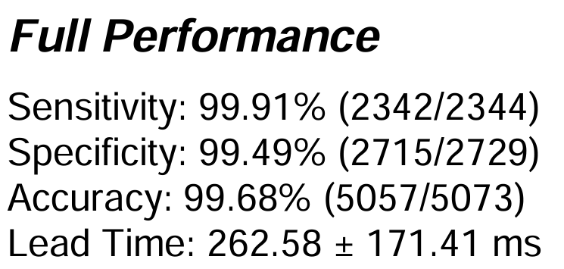

□ Transfer learning model 성능 (KFall Training set + Yonsei ADL)
[기존]
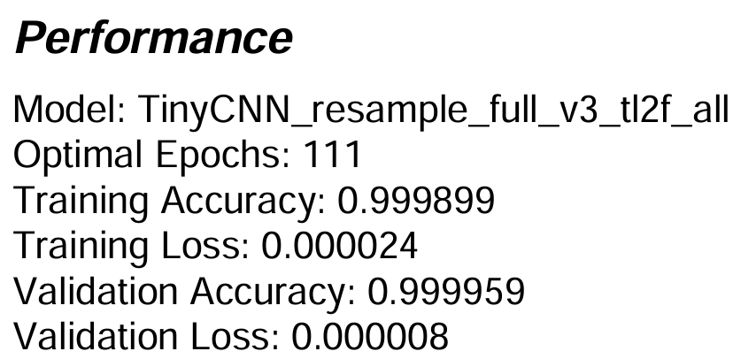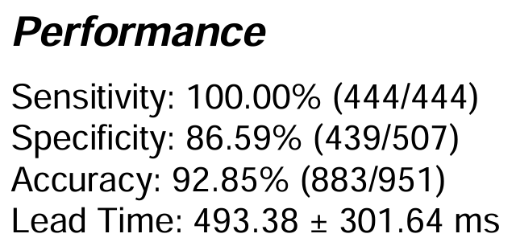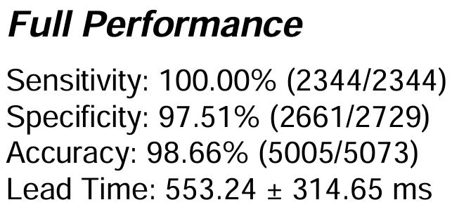
[v2_1]
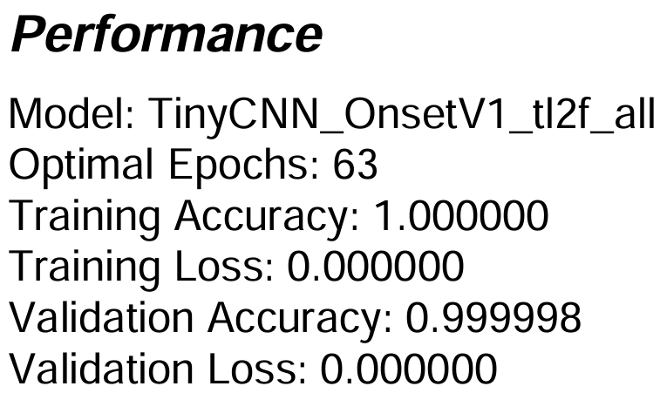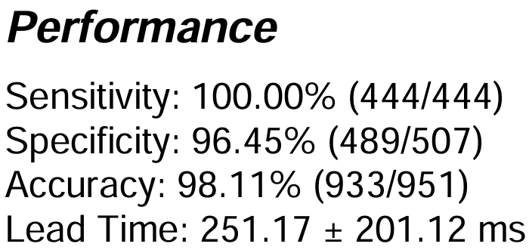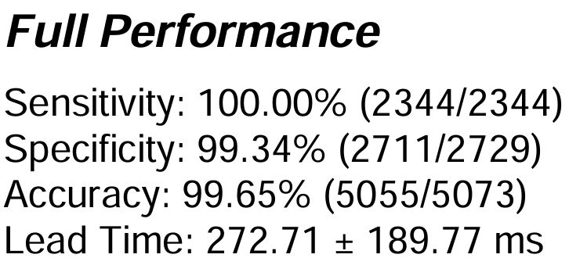
[v2_2]
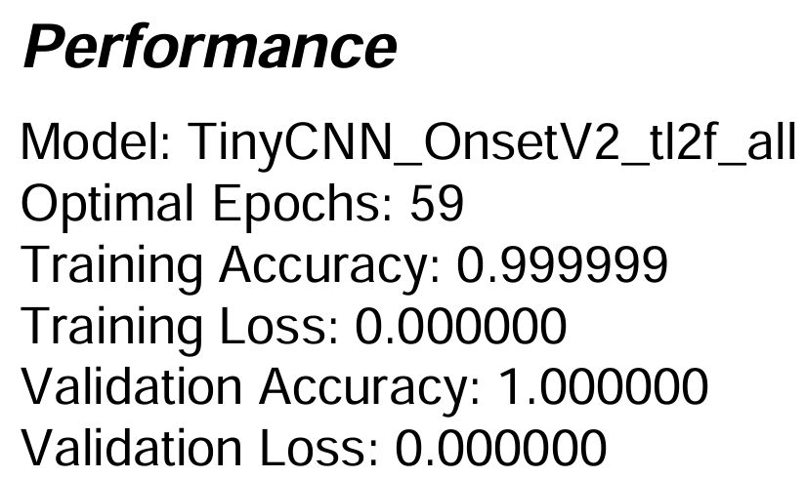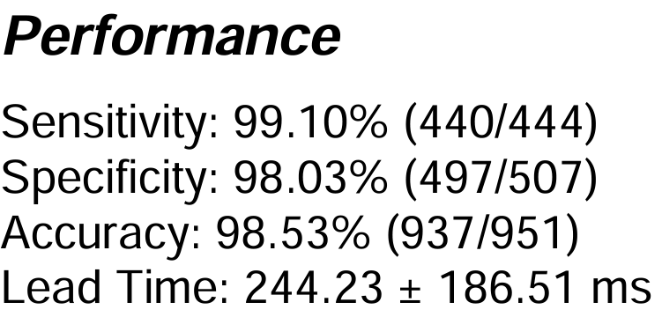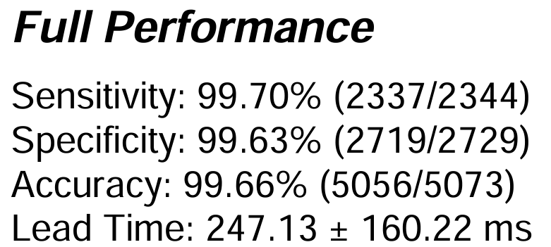

□ Knowledge Distillation model 성능 [기존]
[D1_ALG_1.1.0] Default (alpha=0.8 / gamma=3)
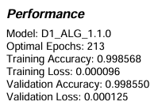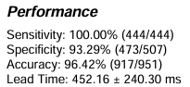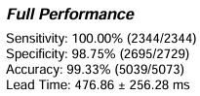
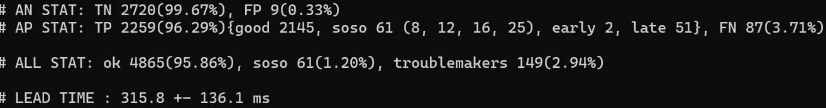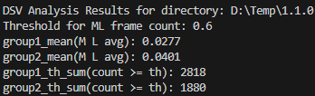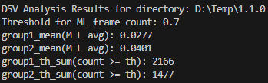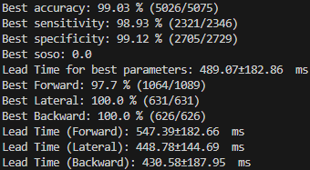
[D1_ALG_2.3.2] Cherry picking + Test03 (alpha=0.2 / gamma=3)
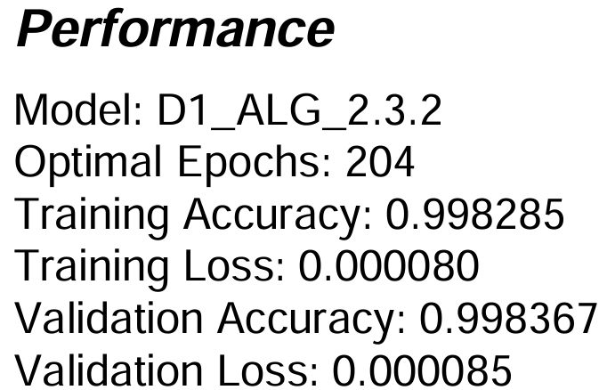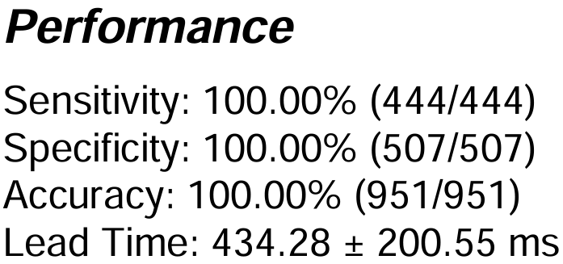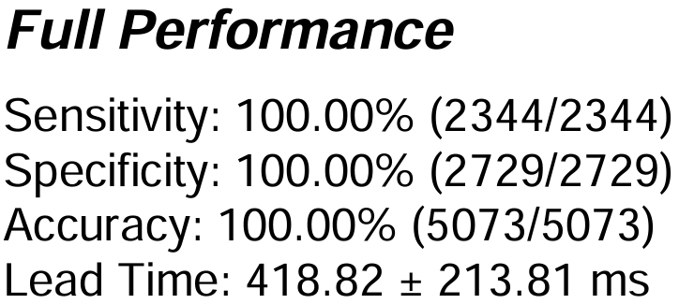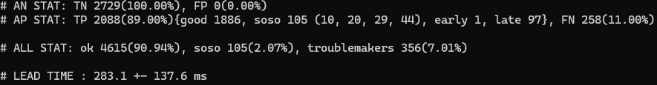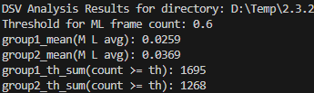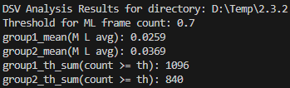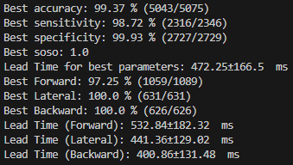
[D1_ALG_2.4.2] Cherry picking + Test01~3 (alpha=0.2 / gamma=3)
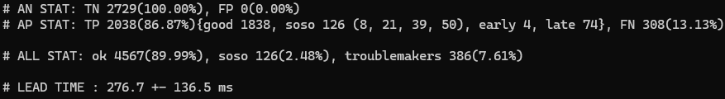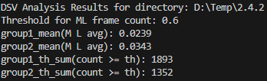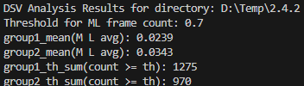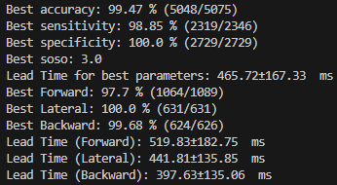
[D1_ALG_2.5.2] Cherry picking X + Test03 (alpha=0.2 / gamma=3)
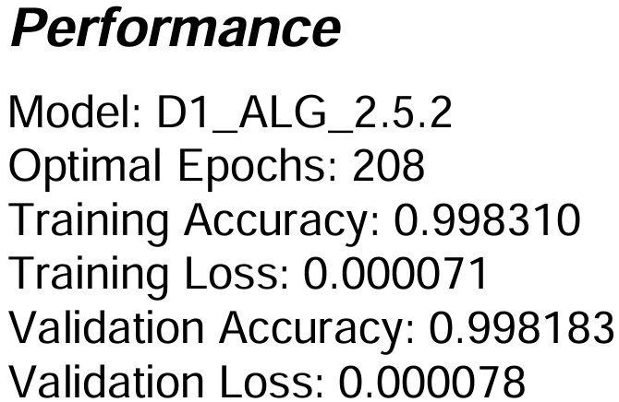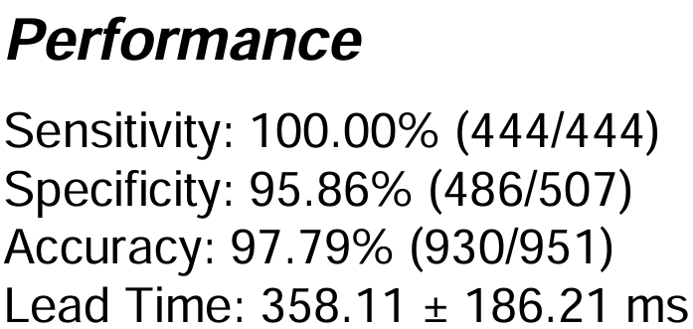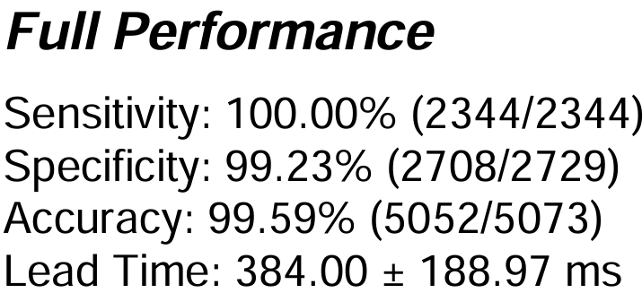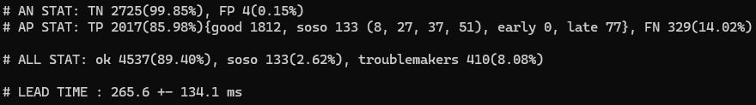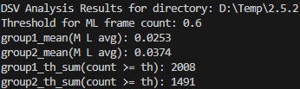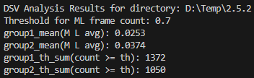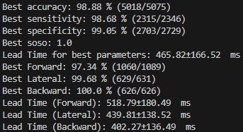

□ Knowledge Distillation model 성능 [v2_1]
[TinyCNN_OnsetV1_kD01] Default (alpha=0.8 / gamma=3) 3.0.0
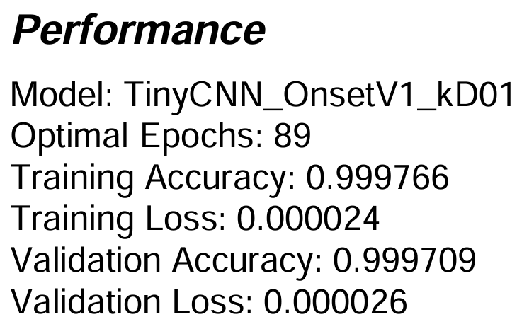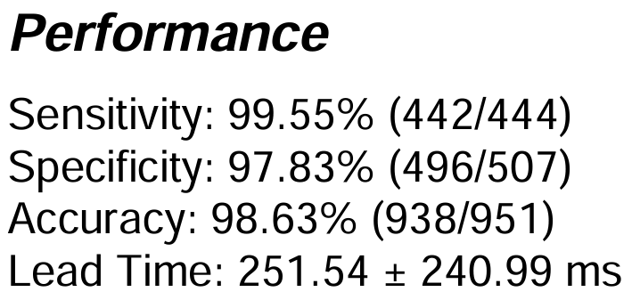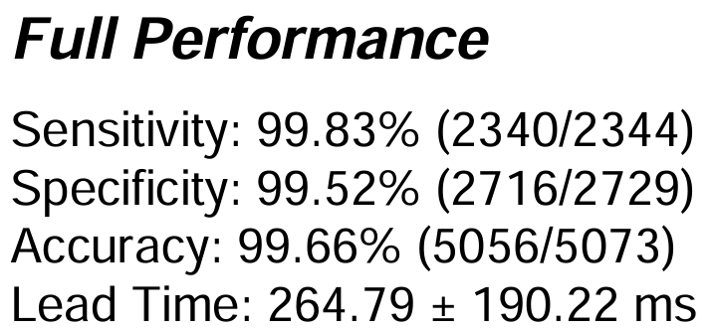
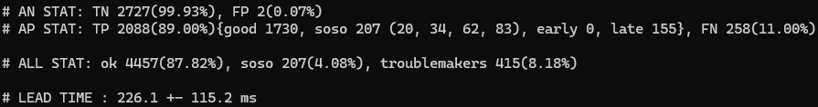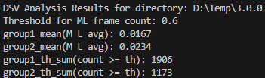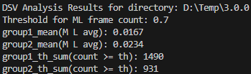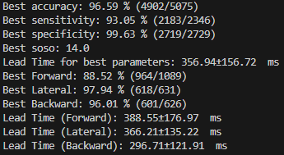
[TinyCNN_OnsetV1_kD02] Cherry picking+Test03 (alpha=0.2 / gamma=3) 3.0.1
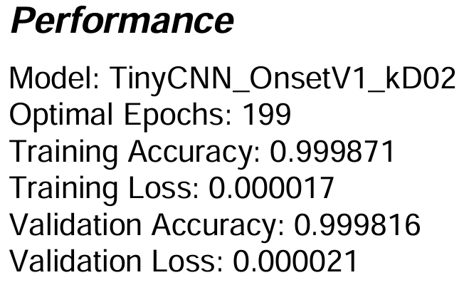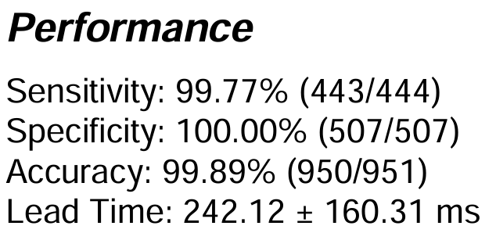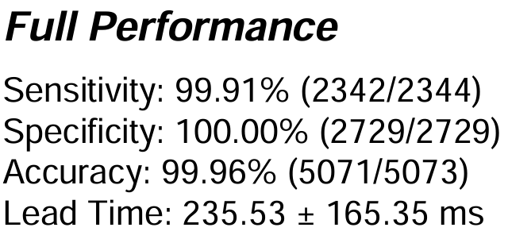
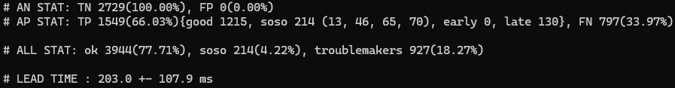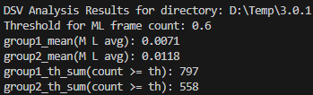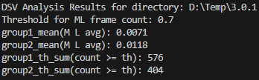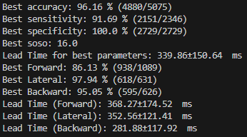

[TinyCNN_OnsetV1_kD02_1] Cherry picking+Test01~3 (alpha=0.2 / gamma=3) 3.0.2
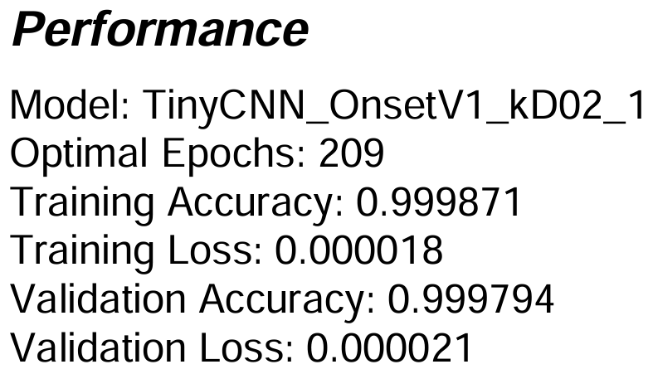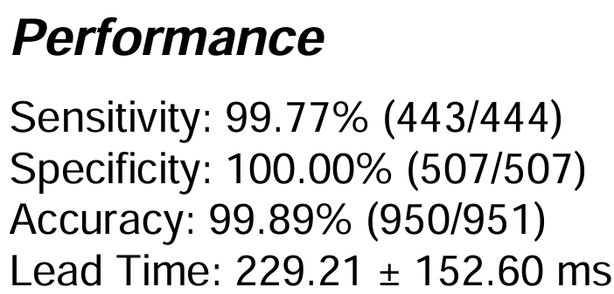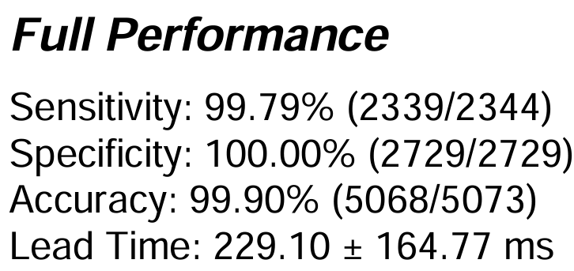
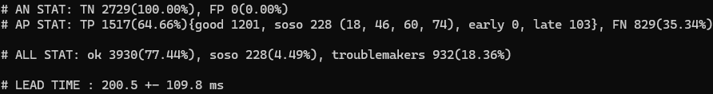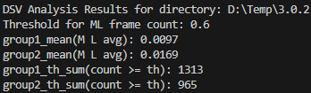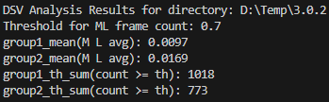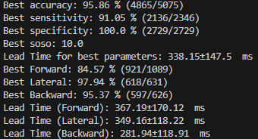
[TinyCNN_OnsetV1_kD03] Cherry picking X+Test03 (alpha=0.2 / gamma=3) 3.0.3
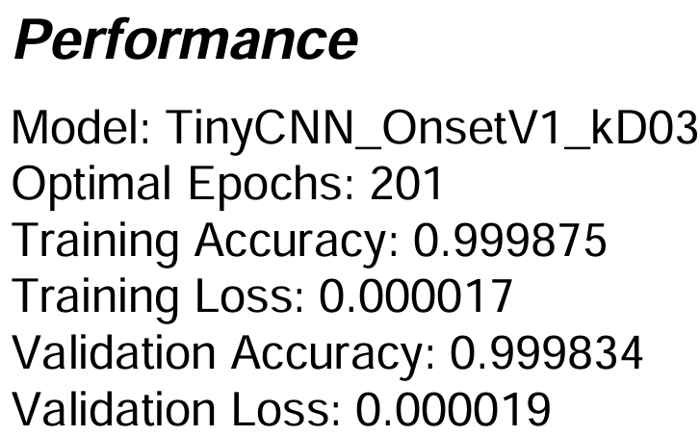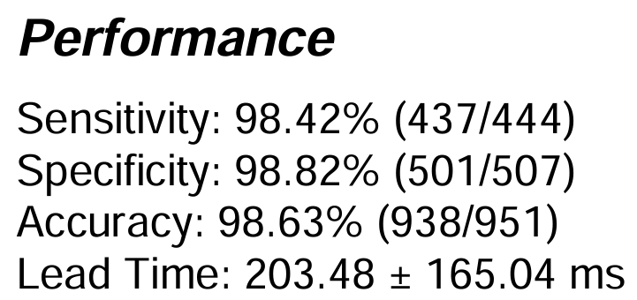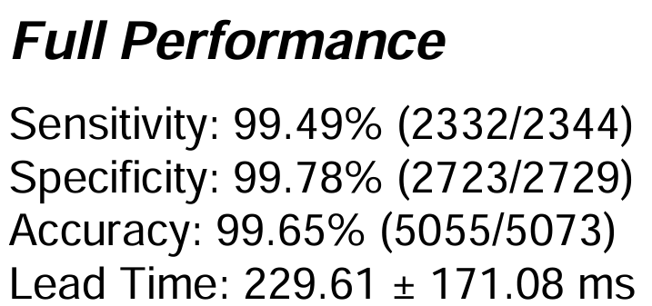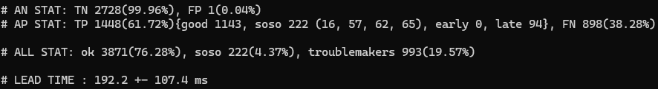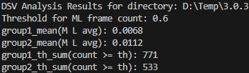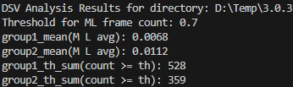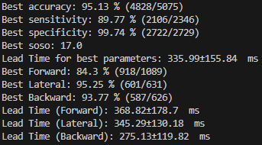

□ Knowledge Distillation model 성능 [v2_2]
[TinyCNN_OnsetV2_kD01] Default (alpha=0.8 / gamma=3) 3.1.0
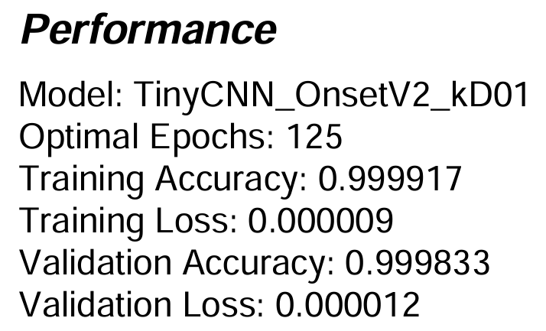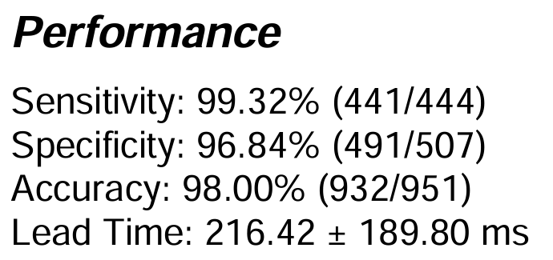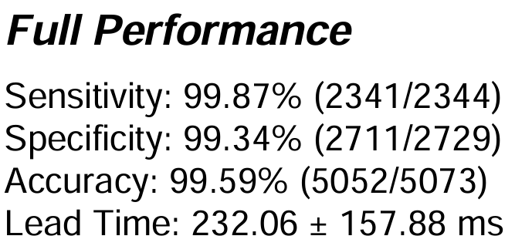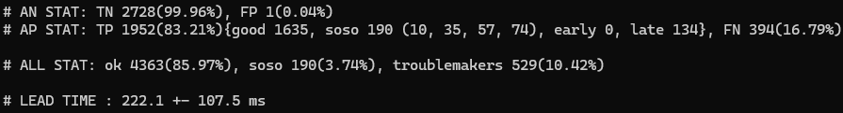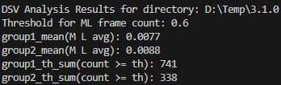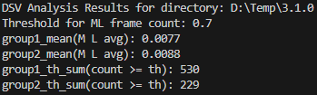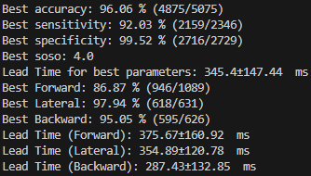
[TinyCNN_OnsetV2_kD02] Cherry picking+Test03 (alpha=0.2 / gamma=3) 3.1.1
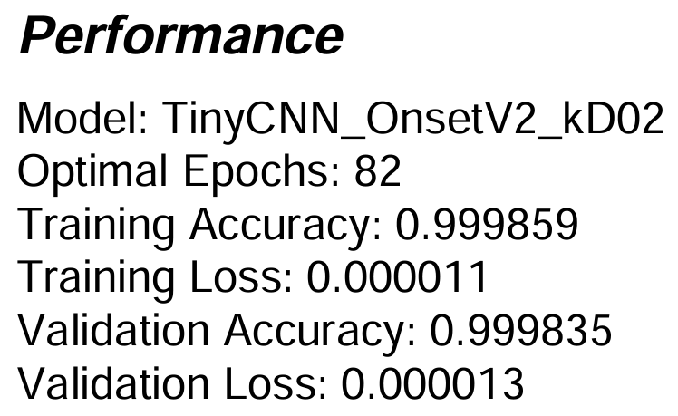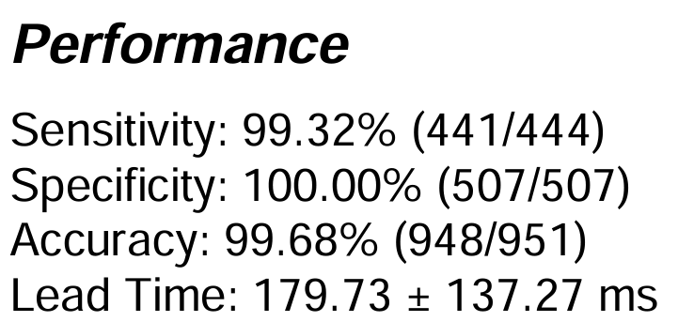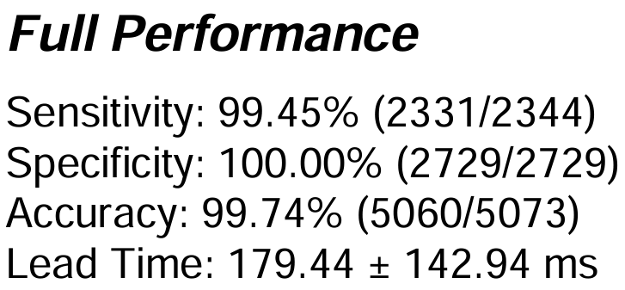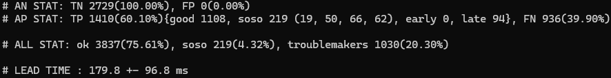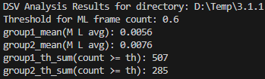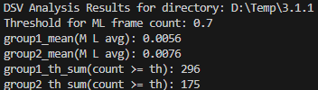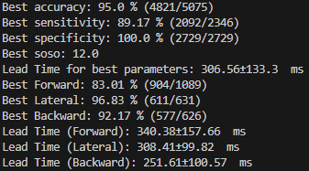

[TinyCNN_OnsetV2_kD02_1] Cherry picking+Test01~3 (alpha=0.2 / gamma=3) 3.1.2
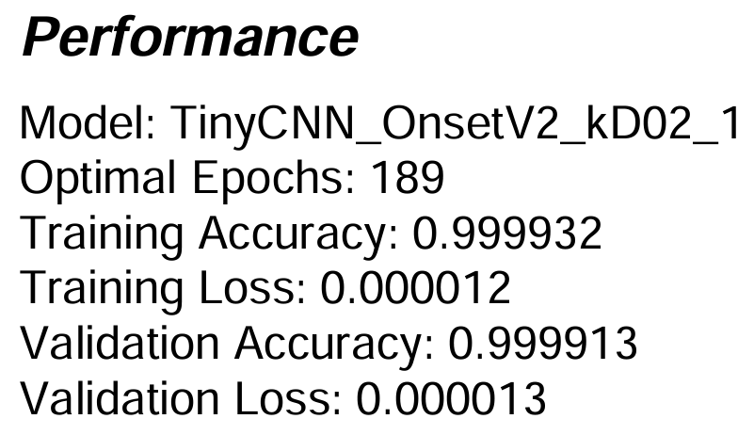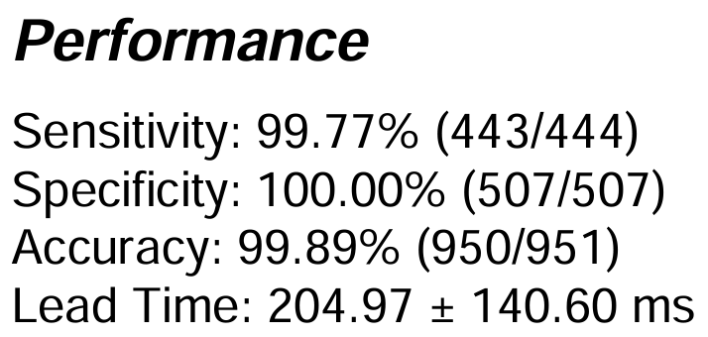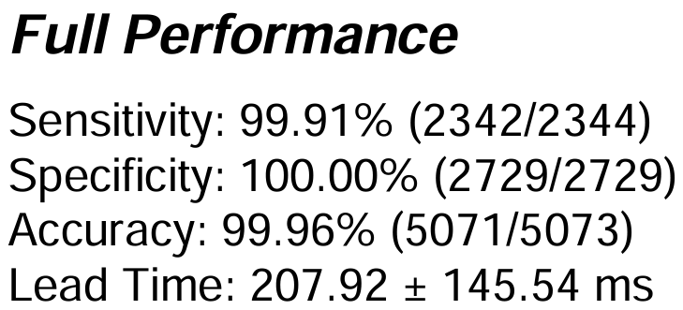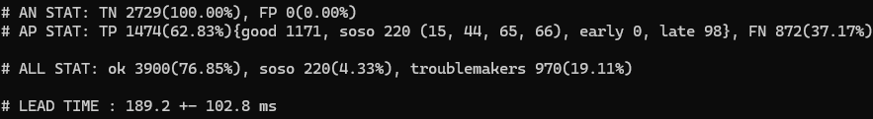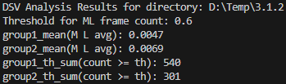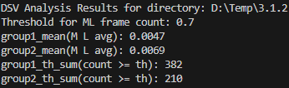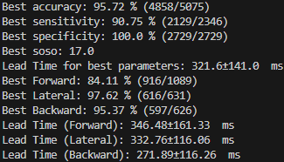
[TinyCNN_OnsetV2_kD03] Cherry picking X+Test03 (alpha=0.2 / gamma=3) 3.1.3


